News Article Classifier

***Wireframe Documentation***

**Home page**

1. This home page that should be available for the user.

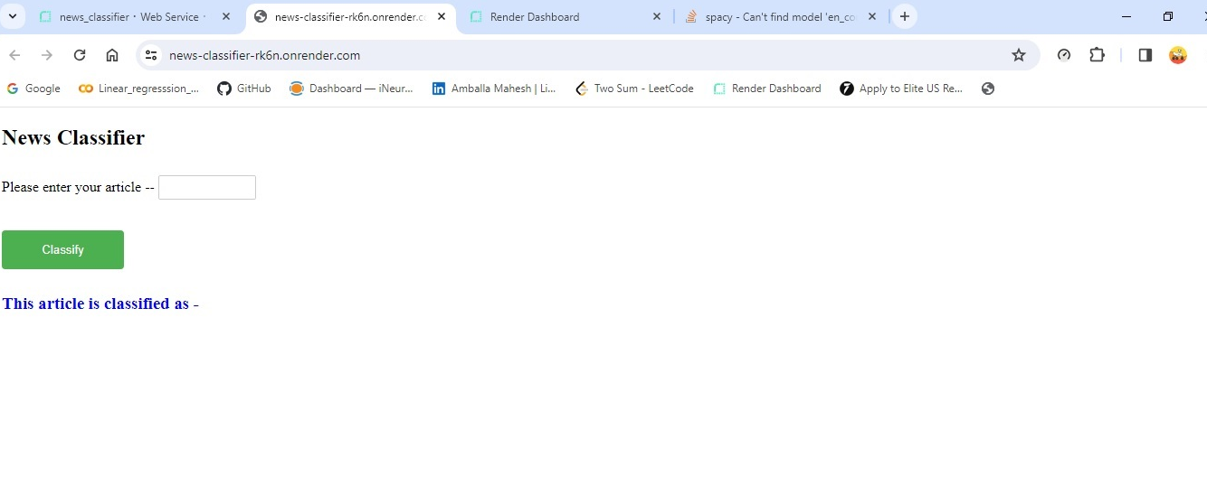

1. The user should get the output as below mentioned.

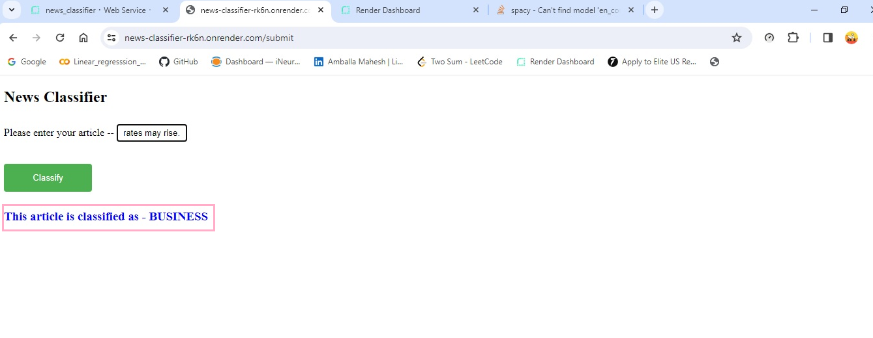

1. Once the classification is done this page is ready to classify an another article.

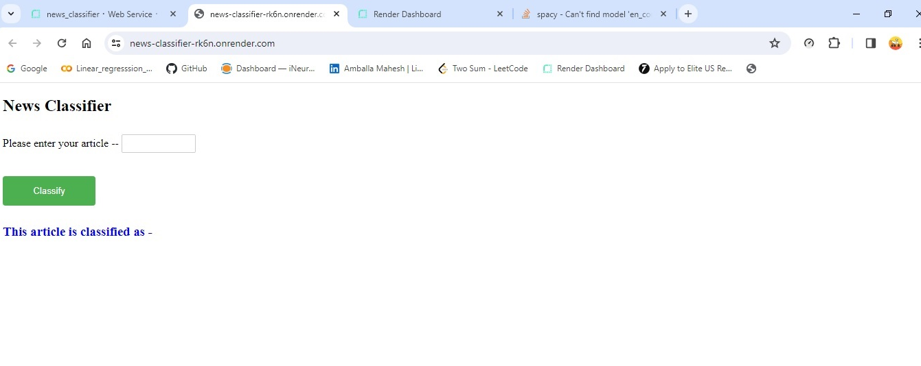

1. Check the logging file whether the logging is active or not.

